1.

Which of the following is the set of prime factors of 12?
A.
{2, 3}
B.
{1, 2, 3}
C.
{1, 2, 4, 6}
D.
{2, 3, 4, 6}

2.

Expand 3a(a – 4b)
A.
3a – 12ab
B.
3a² – 12ab
C.
3a² – 12b
D.
3a² – 12a

3.

Express 5 as a percentage of 4.
A.
125%
B.
120%
C.
25%
D.
20%

4.

Express 2700 as a product of prime numbers.
A.
2² × 3² × 5²
B.
2 × 3³ × 5²
C.
2² × 3³ × 5²
D.
2 × 3² × 5³

5.

The ratio of mangoes to oranges in a basket is 3:2. If there are 36 mangoes, how many oranges are in the basket?
A.
90
B.
60
C.
24
D.
12

6.

Express 0.125 as a fraction in its lowest form.
A.
1
8
B.
1
9
C.
1
12
D.
1
16

7.

Convert 222_{five} to a number in base ten.
A.
30
B.
52
C.
60
D.
62

8.

If A = {18, 19, 20} and B = {15, 16, 17}, find A∩B.
A.
{15, 16, 17, 18, 19, 20}
B.
{15, 16, 18, 19}
C.
{18, 19}
D.
{}

9.

Simplify 3⁹ ÷ 3³
A.
3²⁷
B.
3¹²
C.
3⁶
D.
3³

10.

An article which costs GH¢ 25.00 was sold for GH¢ 35.00. Find the percentage profit made.
A.
10%
B.
28%
C.
40%
D.
70%

11.

Factorize completely b² + fb – mb – fm.
A.
(b – f)(b – m)
B.
(b + f)(b – m)
C.
(b + f)(m – b)
D.
(b + f)(m + b)

12.

Simplify: -13 – (-3) + (-10).
A.
-26
B.
-20
C.
-10
D.
- 6

13.

Find the HCF of 3³ × 5² and 3² × 5⁴.
A.
3^{2 × 52}
B.
3³ × 5²
C.
3² × 5⁴
D.
3⁵× 5⁶

14.

State the rule for the mapping
x | 1 | 2 | 3 | 4
↓ | ↓ | ↓ | ↓ | ↓
y | 15 | 30 | 46 | 60
A.
x → 15x
B.
x → 15 + x
C.
x →
15
x
D.
x → 10 + 5x

15.

Solve the inequality x -
1
3
≥
2
3
- x.
A.
x ≤
1
2
B.
x ≤
2
3
C.
x ≥
1
2
D.
x ≥
2
3

16.

Find the area of a square, if its perimeter is 28 cm.
A.
784 cm²
B.
196 cm²
C.
49 cm²
D.
14 cm²

17.

Simplify:
1
3
(
1
2
−
1
3
)−
1
3
(
1
3
−
1
2
)
A.
-
1
9
B.
-
1
18
C.
1
18
D.
1
9

18.

Make n the subject of the relation θ = 180 -
360
n
A.
θ + 180
2
B.
θ - 180
2
C.
360
180 − θ
D.
360
180 + θ

19.

If R =
h
2
+
d
2
8h
, find R when d = 8 and h = 6.
A.
3
1
6
B.
4
1
3
C.
4
3
4
D.
4
9
16

20.

Eight copies of a book cost GH₵ 16.00. Find the cost of 5 copies.
A.
GH₵ 2.00
B.
GH₵ 3.20
C.
GH₵ 5.00
D.
GH₵ 10.00

21.

Solve the equation
1
5
(2 + y) =
1
2
(y -1).
A.
-3
B.
-
3
4
C.
5
3
D.
3

22.

The gradient of the straight line that passes through points A(3,2) and B(4,8) is
A.
-
1
6
B.
-
1
2
C.
2
D.
6

23.

A car is travelling at 60 km per hour. How far does it travel in 2
1
2
hours?
A.
30 km
B.
60 km
C.
120 km
D.
150 km

24.

In the following diagram RS and WV are parallel lines. The value of the angle marked α is
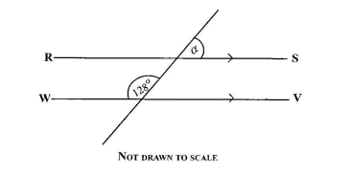
A.
38º
B.
52º
C.
58º
D.
64º

25.

Given that a =
(
5
2n
)
and b =
(
2n -1
6
)
.
If a = b, find the value of n.
A.
6
B.
3
C.
2
D.
1

26.

Find the volume of a cube of side 5 cm.
A.
10 cm³
B.
15 cm³
C.
25 cm³
D.
125 cm³

27.

In the diagram below, AB and CD are two intersecting straight lines. Find the value of the angle marked y.
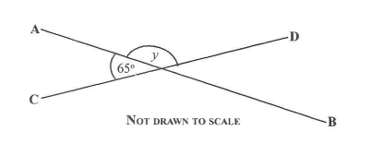
A.
130º
B.
115º
C.
65º
D.
60º

28.

Kwame and Ama shared an amount of money in the ratio 5:4 respectively. If Kwame had GH₵ 9.00, how much did they share?
A.
GH₵ 16.20
B.
GH₵ 36.00
C.
GH₵ 45.00
D.
GH₵ 81.00

29.

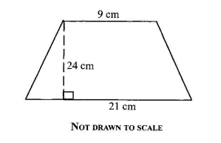
The area of the trapezium above is
A.
120 cm²
B.
180 cm²
C.
256 cm²
D.
360 cm²

30.

If r =
(
2
-5
)
and s =
(
-2
5
)
, calculate 2r - 3s.
A.
(
-10
-25
)
B.
(
-2
-25
)
C.
(
10
-25
)
D.
(
10
25
)

31.

There are 10 red and 15 green balls in a bag. Find the probability of selecting at random a red ball from the bag.
A.
3
5
B.
2
5
C.
1
10
D.
1
25

32.

The table below gives the distribution of ages of students in a class.
Use it to answer the question below.
Ages (years) | 13 | 14 | 15 | 16 | 17
Number of students | 3 | 10 | 6 | 7 | 4
How many students are in the class?
A.
20
B.
30
C.
45
D.
75

33.

The table below gives the distribution of ages of students in a class.
Use it to answer the question below.
Ages (years) | 13 | 14 | 15 | 16 | 17
Number of students | 3 | 10 | 6 | 7 | 4
What is the modal age?
A.
14
B.
15
C.
16
D.
17

34.

The table below gives the distribution of ages of students in a class.
Use it to answer the question below.
Ages (years) | 13 | 14 | 15 | 16 | 17
Number of students | 3 | 10 | 6 | 7 | 4
If a student is selected at random from the class, what is the probability that the student is 15 years old?
A.
1
5
B.
1
3
C.
1
2
D.
2
3

35.

A length of a ribbon is 16.8 m long. How many ribbons 0.36 m long can be cut from it?
A.
0.46
B.
4.60
C.
46
D.
460

36.

A refrigerator was sold for GH₵ 200.00 at a loss of 10%. Find the cost price.
A.
GH₵ 180.00
B.
GH₵ 190.48
C.
GH₵ 220.00
D.
GH₵ 222.22

37.

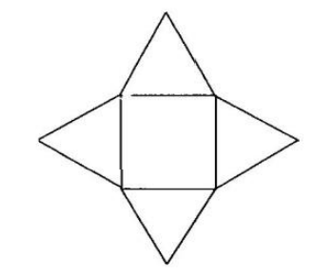
The diagram above is the net of a
A.
cone.
B.
cuboid.
C.
rectangular prism.
D.
pyramid

38.

What is the value of 7 in the number 832713?
A.
Seven thousand
B.
Seven hundred
C.
Seventy
D.
Seven

39.

Write 3560 in standard form.
A.
3.56 x 10⁻⁴
B.
3.56 x 10⁻³
C.
3.56 x 10³
D.
3.56 x 10⁴

40.

Correct 0.02751 to three decimal places.
A.
0.027
B.
0.028
C.
0.03
D.
0.28

